Lab A: Planning an IPv4 network

**Scenario**

A. Datum Corporation is an international organization with its North American regional office located in

Toronto. They are planning to open three branch offices in different cities in North America. The branch

offices will be located in Houston, Mexico City, and Portland.

The following table describes the planned computer distribution in the branch offices.

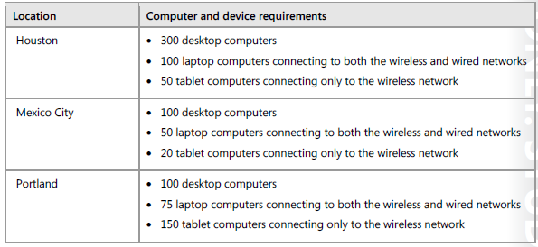

A. Datum is using Microsoft Office 365 for all email and file access for the North American branch offices,

with some shared folders located in the Toronto regional office on servers running the Windows Server

operating system. Because all offices have fast and highly available network connections to the Toronto

office, A. Datum is not planning to deploy any servers in the branch offices at this point.

The A. Datum network team has assigned the subnets 172.16.18.0/18 to the Toronto regional office. The

Toronto office is currently using the network assignments shown in the following table.

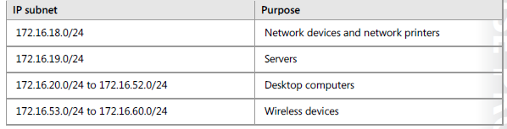

You need to plan an IPv4 address assignment for each of the branch offices, using IP addresses from the

list of addresses assigned to the Toronto office. You also need to ensure that the IP addresses assigned to

computers connected to wired connections differ from the IP addresses assigned to devices connected to

the wireless networks.

**Lab Setup**

**Estimated Time: 30 minutes**

**Exercise 1: Planning the IPv4 address assignments**

**Scenario**

You need to plan the IP address assignment for each North American branch office. Your IP addressing

scheme must meet the following requirements:

• Wired and wireless clients must be assigned IP addresses from different IP address ranges.

• Each branch office location should have dedicated IP address ranges.

• Keep subnets in branch office locations as simple as possible.

• Ensure that branch office subnets have IP addresses for all potential wired and wireless clients that

might request an IP address.

The main task for this exercise is as follows:

1. Plan the IPv4 implementation.

** Task 1: Plan the IPv4 implementation**

1. How will you determine the number of IP addresses required for each location?

2. How do the laptops that have both wired and wireless network adapters affect the number of IP

addresses required?

3. What is the simplest subnet class to use when planning an IP addressing scheme for each of the

North America branch locations?

4. In the Houston office, what is the number of potential wired and wireless clients?

5. In the Houston office, how many /24 subnets are required for wired connections? How many are

required for wireless?

6. In the Mexico City office, what is the number of potential wired and wireless clients?

7. In the Mexico City office, how many /24 subnets are required for wired connections? How many for

wireless?

8. In the Portland office, what is the number of potential wired and wireless clients?

9. In the Portland office, how many /24 subnets are required for wired connections? How many for

wireless?

10. Given the assigned IP range of 172.16.20.0/24 – 172.16.52.0/24 for wired clients, which subnets will

you use for the Houston, Mexico City, and Portland offices?

11. Given the assigned IP range of 172.16.53.0/24 – 172.16.60.0/24 for wireless clients, which subnets will

you use for the Houston, Mexico City, and Portland offices?